Ideation Phase

Define the Problem Statements
Date | 29 September 2026
Team ID | 6ab1d50c92b876d9664094bc
Project Name | Auto Ticket Classification Using Flow Designer
Maximum Marks | 2 Marks

Customer Problem Statement Template
Identify the challenges faced by IT support agents and employees when incoming support tickets are manually classified and assigned. The proposed project uses ServiceNow Flow Designer to automate ticket categorization and routing based on predefined conditions.
Reference template: https://miro.com/templates/customer-problem-statement/
Problem Statement (PS) | I am (Customer) | I’m trying to | But | Because | Which makes me feel
PS-1 | An IT support agent | Classify and route incoming tickets quickly | Manual classification takes time and may cause wrong assignments | Ticket descriptions vary and there is no consistent automated routing | Frustrated by delays and reassignment
PS-2 | An employee raising a ticket | Get my issue to the right team promptly | My ticket may remain unassigned or reach the wrong team | Manual triage does not consistently identify categories and assignment groups | Uncertain about resolution time

Problem-to-Solution Workflow Diagram
Proposed workflow for addressing the customer problems identified in PS-1 and PS-2.
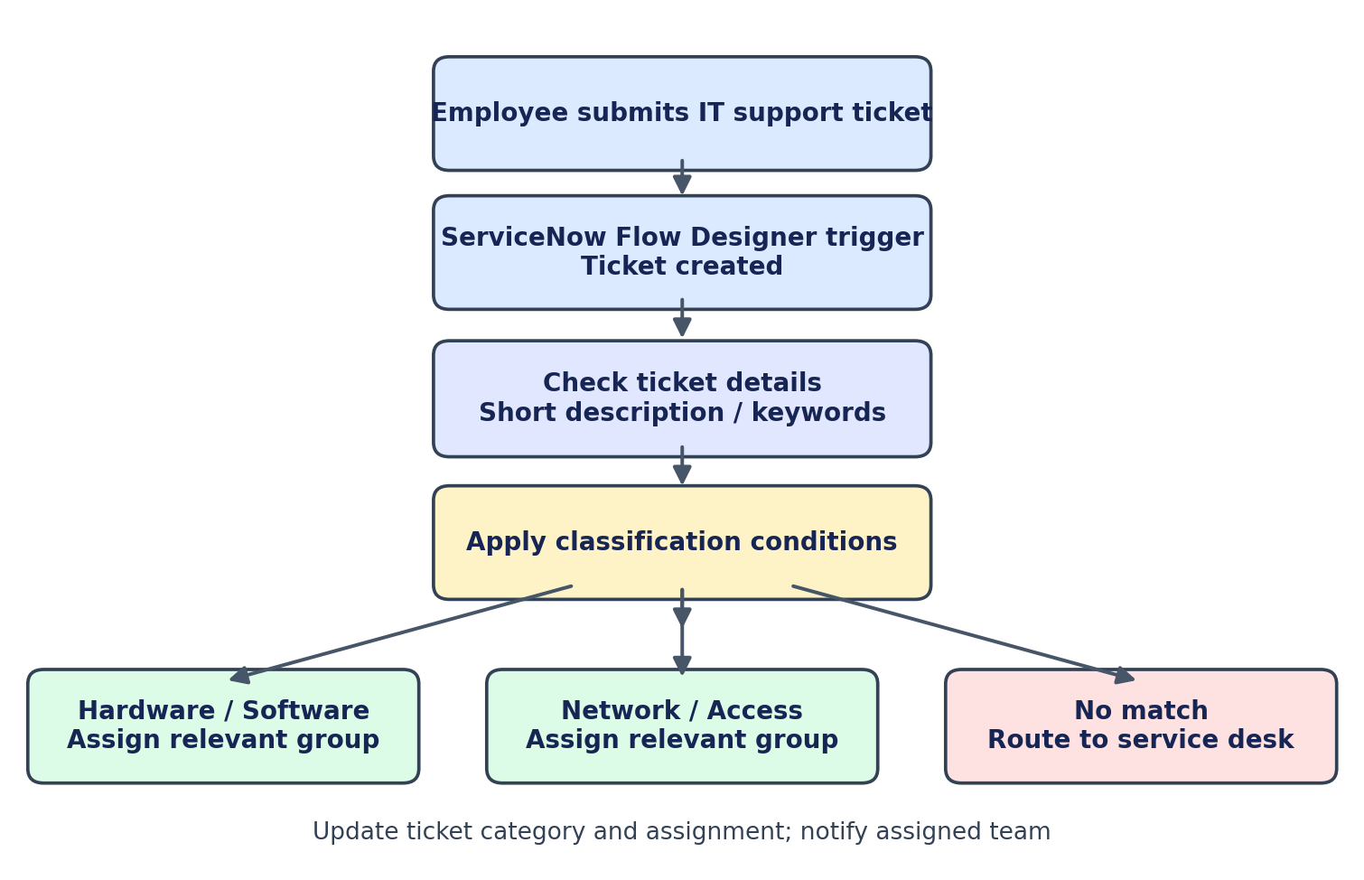
Note: Classification rules and assignment groups are illustrative and can be configured according to the organization’s ticket categories.

